Game of The Amazons
Amazons - Project Description

Course: Artificial Intelligence
Professor: Prof. Dr. Izudin Džafić
Students: Emin Hadžiabdić, Armin Memišević, Muhammed Pašić
Academic year: 2025/26
Student IDs: 19960, 20016, 20109
Table of Contents
Project Overview 2
Proposed vs. Delivered 2
Logic Implementation 3
Algorithm + Heuristics Implementation 4
Board Size and Style Implementation 6
Game Modes and Difficulties Implementation 7
Team Responsibilities and Task Distribution 8

Project Overview

The Game of the Amazons is a strategy board game for two players, traditionally played on a 10x10 board (though our version supports 6x6 and 8x8). It is a "territory-capture" game with no pieces removed from the board.

Proposed vs. Delivered

Feature | Initial Proposal | Final (+additionally implemented)
Logic/Intercation | Interactive Queens, Highlights for valid moves, Selection of moves. | Implemented + Undo Move + Move History + Rules Page
AI Algorithm | Minimax + Alpha-Beta. | Implemented + Stop AI feature
Heuristics | Mobility, Territory, Spatial | Implemented
Difficulty Levels | Easy, Medium, Hard | Implemented
Board Size | 10x10, 8x8, 6x6 | Implemented
Game Modes | Player vs AI | Implemented + PvP, AIvsAI, Animation Speed
Themes | 2 Styles (Wooden/B&W). | Expanded: 8 Styles + Theme Creator with color pickers.
Accessibility | 2 Languages (EN/BS). | Expanded: 6 Languages (EN, BS, DE, ES, FR, JP).
Animations | Shooting Arrow, Field explosion, Moving Queens. | Implemented
Sound Effects | Animations + Win/Loss | Implemented

Logic Implementation

In the initial proposal, the scope of the logic was limited to interactive Queen movement, move validation, and basic selection. The final implementation significantly expanded this foundation to include a robust state-management system that supports Undo functionality, a detailed Move History Log, and an interactive Rules Page.
Core Logic & Validation: The game rules are encapsulated in the Rules.h file. We implemented a "Ray-Casting" approach for move generation. Since Queens and Arrows move identically to Chess Queens, the system scans all 8 directions (orthogonal and diagonal) to collect reachable tiles. A move is only valid if both the Queen's path to the destination and the Arrow's path from that destination are unobstructed.
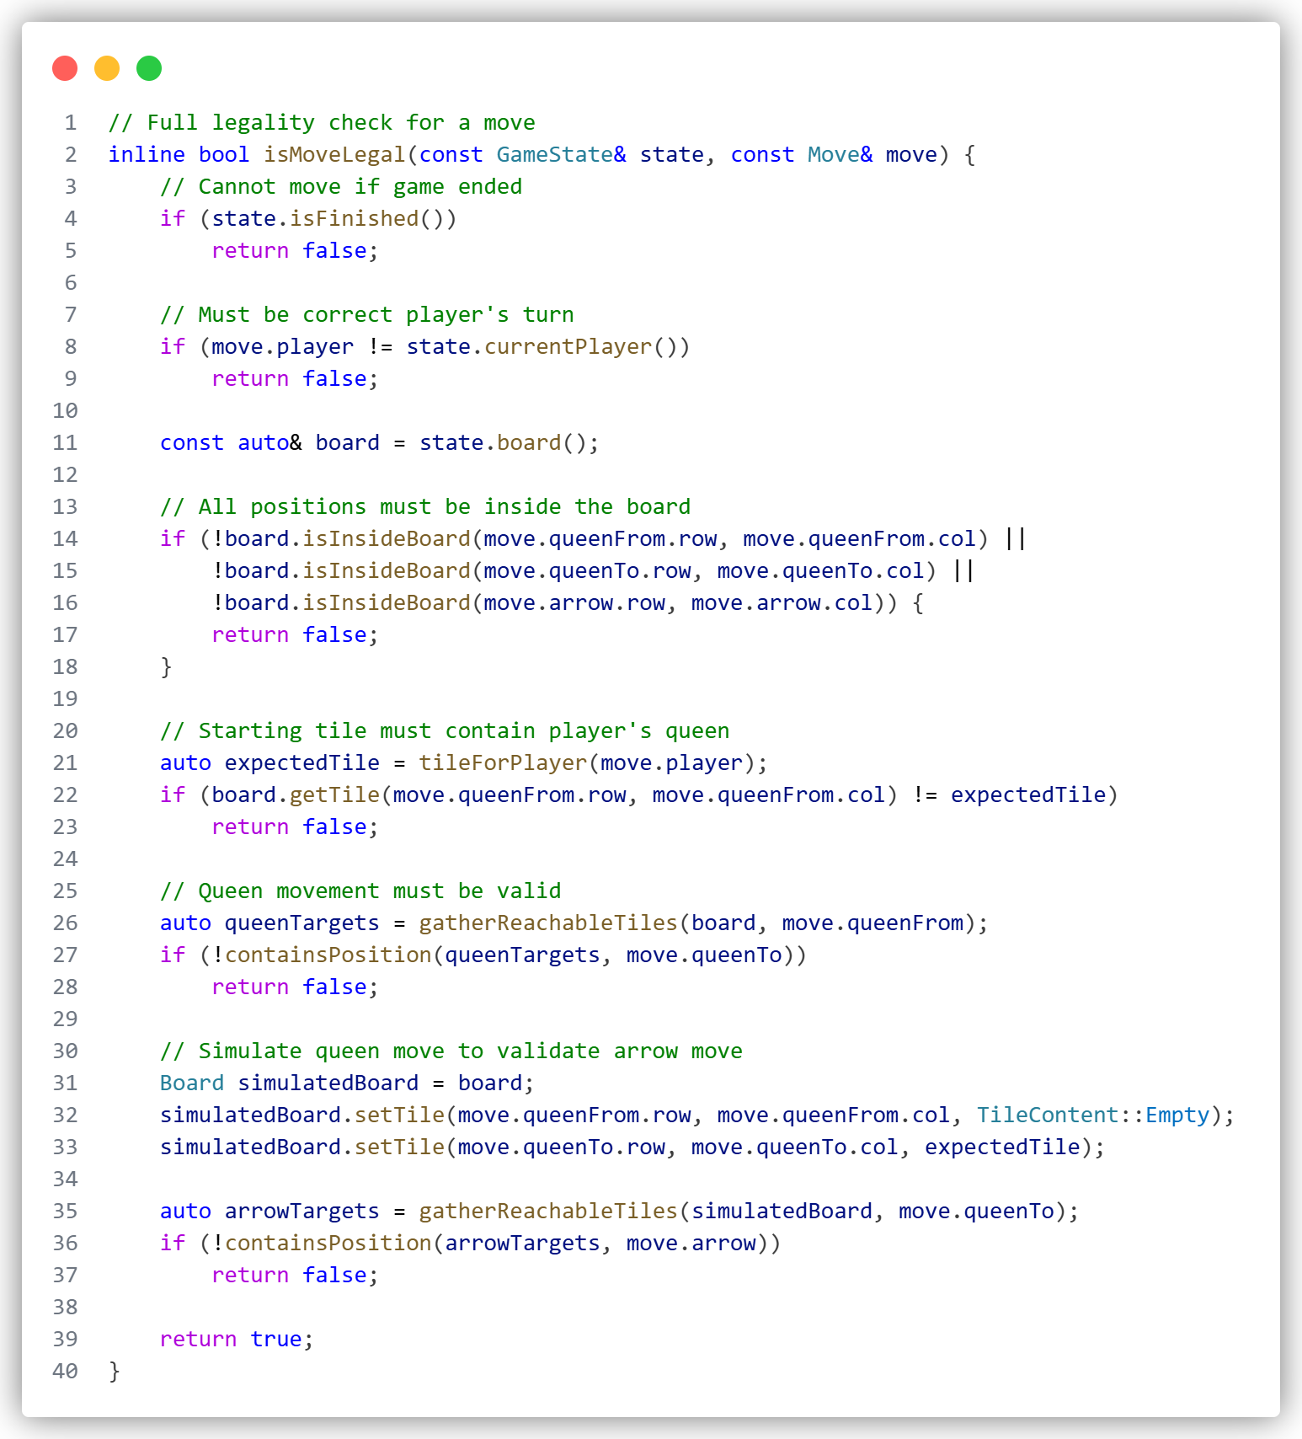
State Management (Undo & History): To support the "Undo" feature (which was not in the original proposal), we implemented a state-stack architecture in GameState.h. Every time a move is committed, the Move object is pushed into a _moveHistory vector. This allows the game to revert to any previous state by popping the last move and refreshing the board. This history is also visualized in the Logs View, providing players with a text-based record of the match (e.g., "Queen (4,1) -> (4,4), Arrow -> (5,5)").
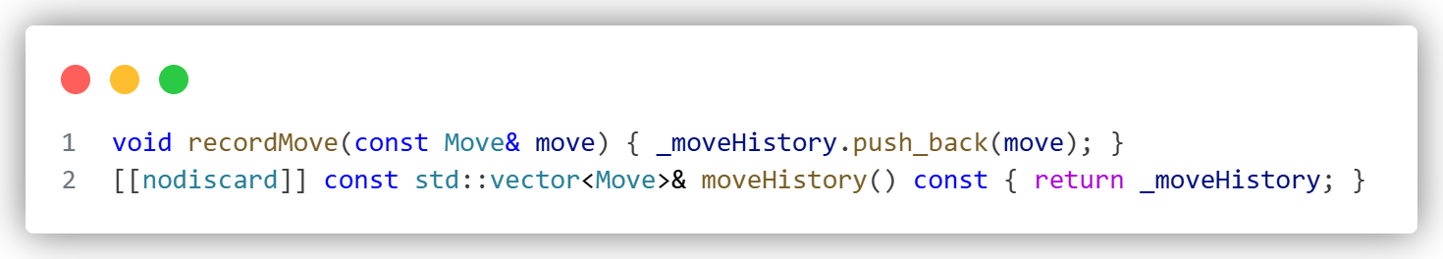

Algorithm + Heuristics Implementation

The core requirement was a Minimax algorithm with Alpha-Beta pruning. We delivered this but added critical enhancements for performance and user experience, specifically the Stop AI feature and advanced heuristic tiers.
Search Engine & Safety: The AI runs on a separate thread to keep the UI responsive. We implemented a safety mechanism using std::atomic_bool _cancelAi in MainView.h and Algorithms.h. This allows the user to interrupt the AI immediately (e.g., by clicking "Stop AI" or "New Game") without crashing the application, a feature essential for handling the high branching factor of 10x10 games.
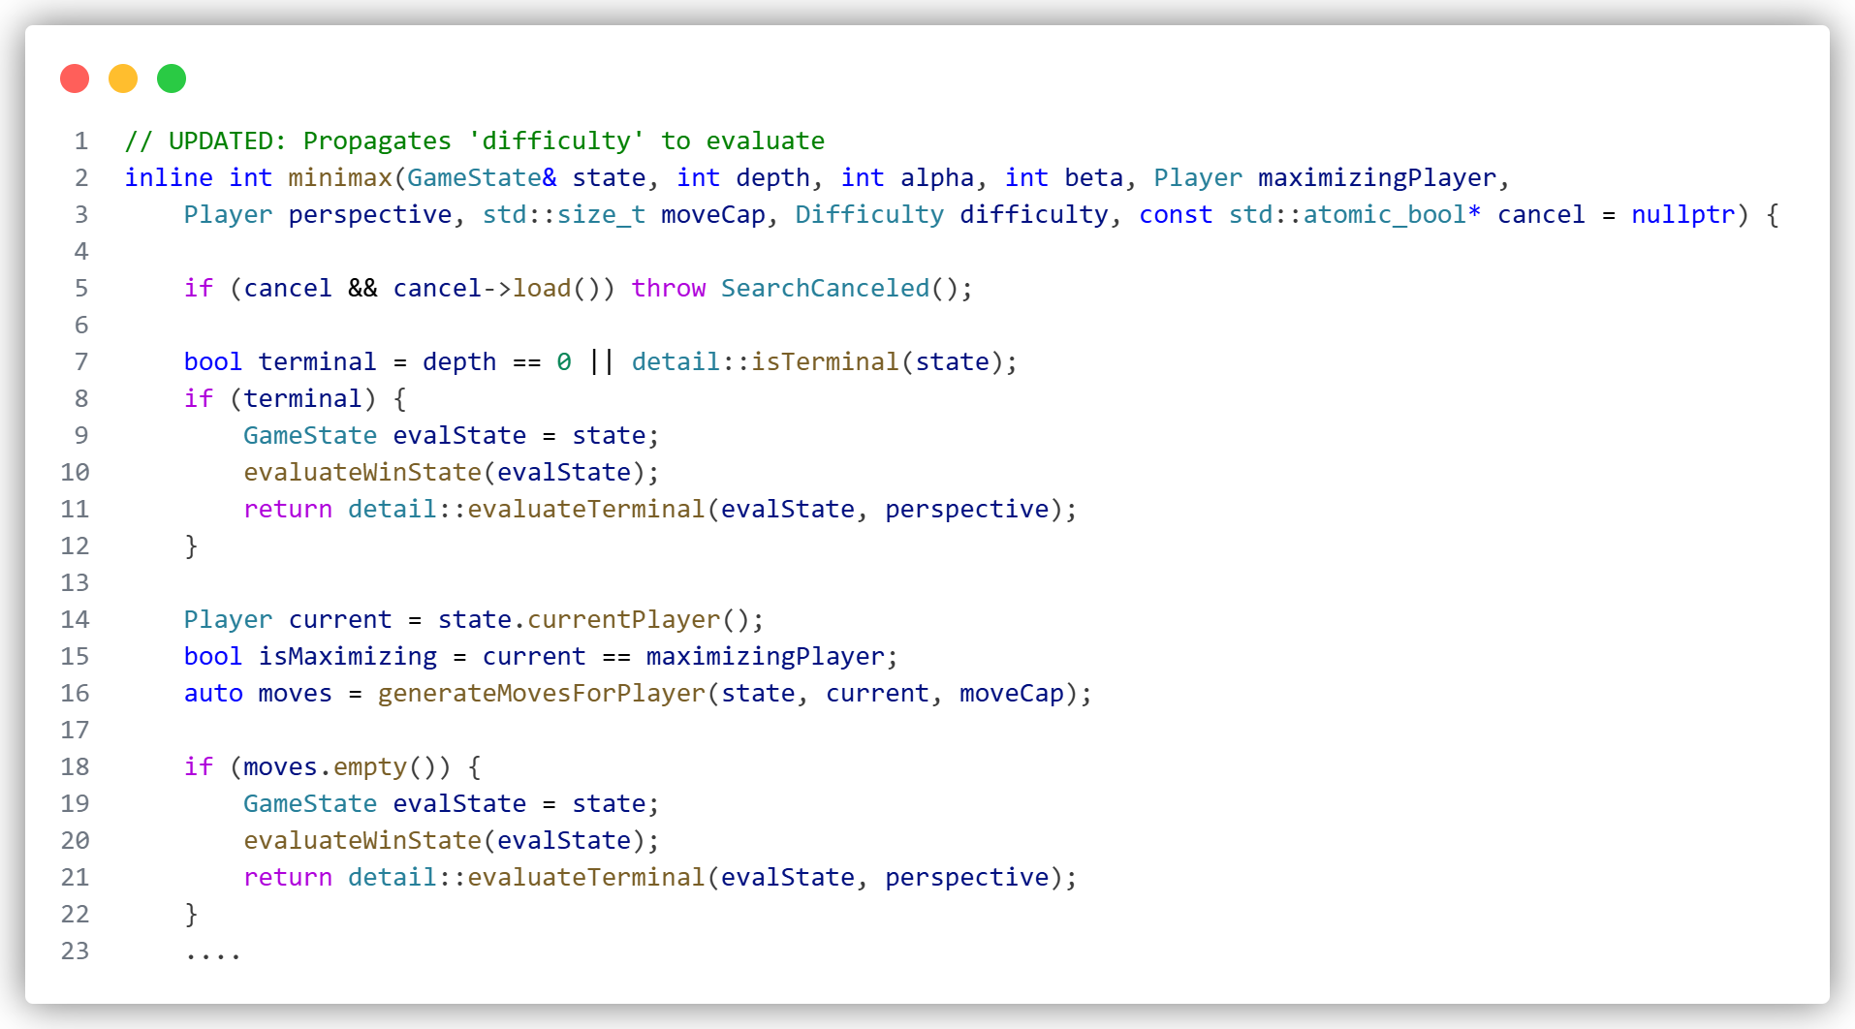
Heuristics (Intelligence Layers): We moved beyond simple mobility counting by implementing three distinct evaluation strategies based on difficulty :
- Mobility (Easy): Simply counts available moves.
- Spatial Influence (Medium): Calculates a score based on how close pieces are to the center and how much board area they "influence" or shadow.
- Territory Control (Hard): Implements a "flood-fill" algorithm to determine which parts of the board are reachable only by the AI. This allows the Hard bot to trap opponents by sealing off entire sections of the board.
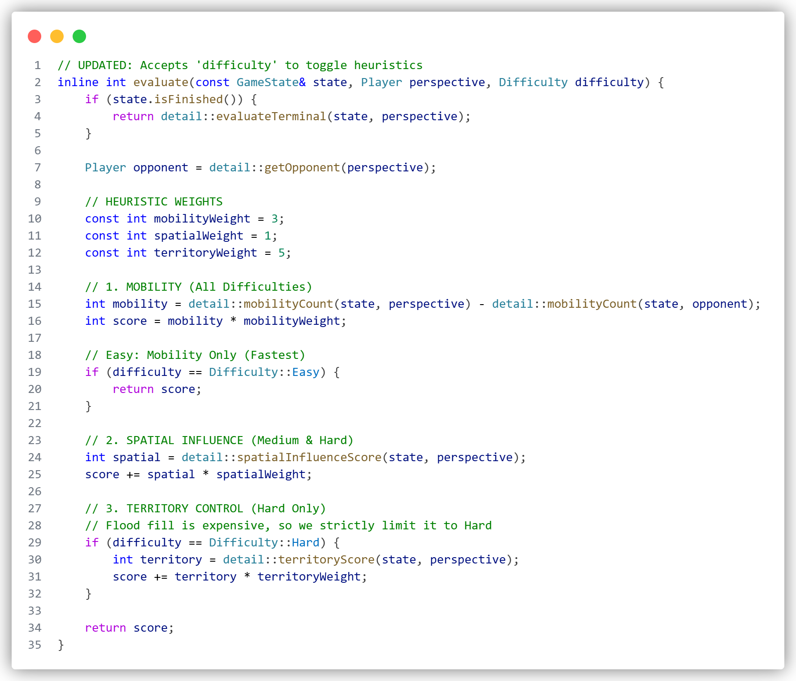

Board Size and Style Implementation

The proposal listed three board sizes and two basic themes. The final product expanded this significantly to include 8 distinct themes and a Custom Theme Creator, providing a highly polished visual experience.
Dynamic Board Geometry: The board rendering in AmazonsBoardCanvas.h is mathematically dynamic. Regardless of whether the user selects 6x6, 8x8, or 10x10, the computeBoardGeometry function calculates the optimal cell size to fit the window while maintaining a perfect square aspect ratio. This ensures the game looks correct on any screen size.
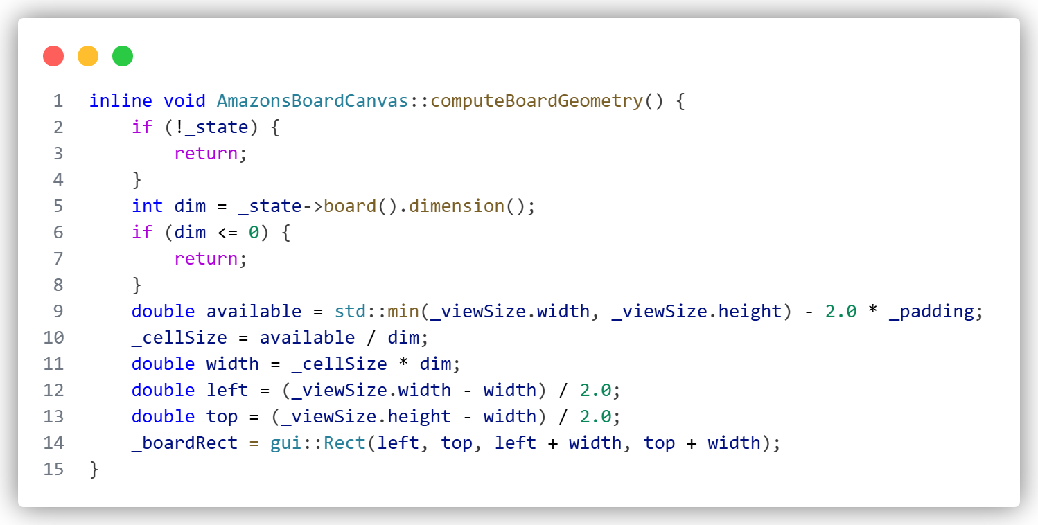
Theme Engine: We implemented a flexible resource loading system. Users can switch between image-based themes (Wooden, Ice, Stone, etc.) and color-based themes (Bubblegum, Black & White). The standout addition is the Custom Theme, which uses the SettingsPopup to pass user-selected ColorIDs to the canvas. This allows users to mix and match any color combination for light and dark tiles using the integrated color pickers.
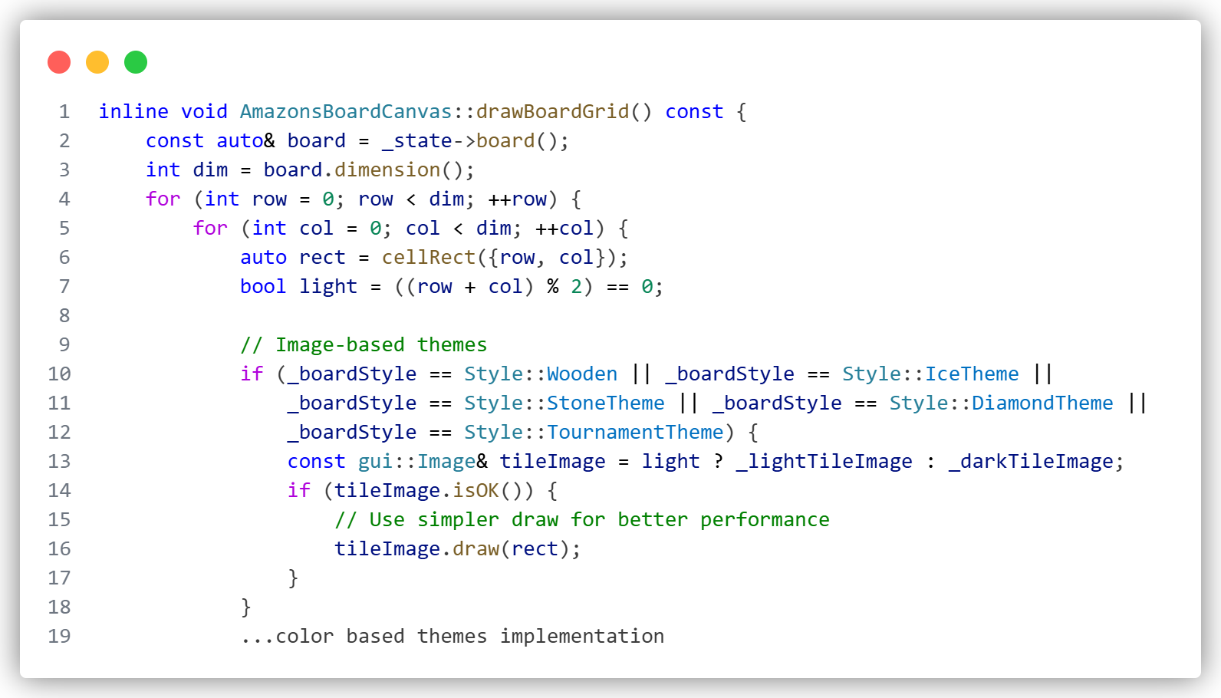

Game Modes and Difficulties Implementation

We exceeded the standard Player vs. AI requirement by implementing a fully flexible "Player Type" system. This allows for PvP (local multiplayer), PvA (standard), and AvA (Spectator Mode).
Player Type Architecture: In MainView.h, we track _whitePlayerType and _blackPlayerType (Human or AI). The game loop checks these flags after every move. If the current player is AI, it triggers the background thread; otherwise, it enables mouse interaction for the human. This architecture also supports the added Animation Speed feature, allowing users to slow down AI matches (up to 3000ms delay) to observe the strategy in real-time.
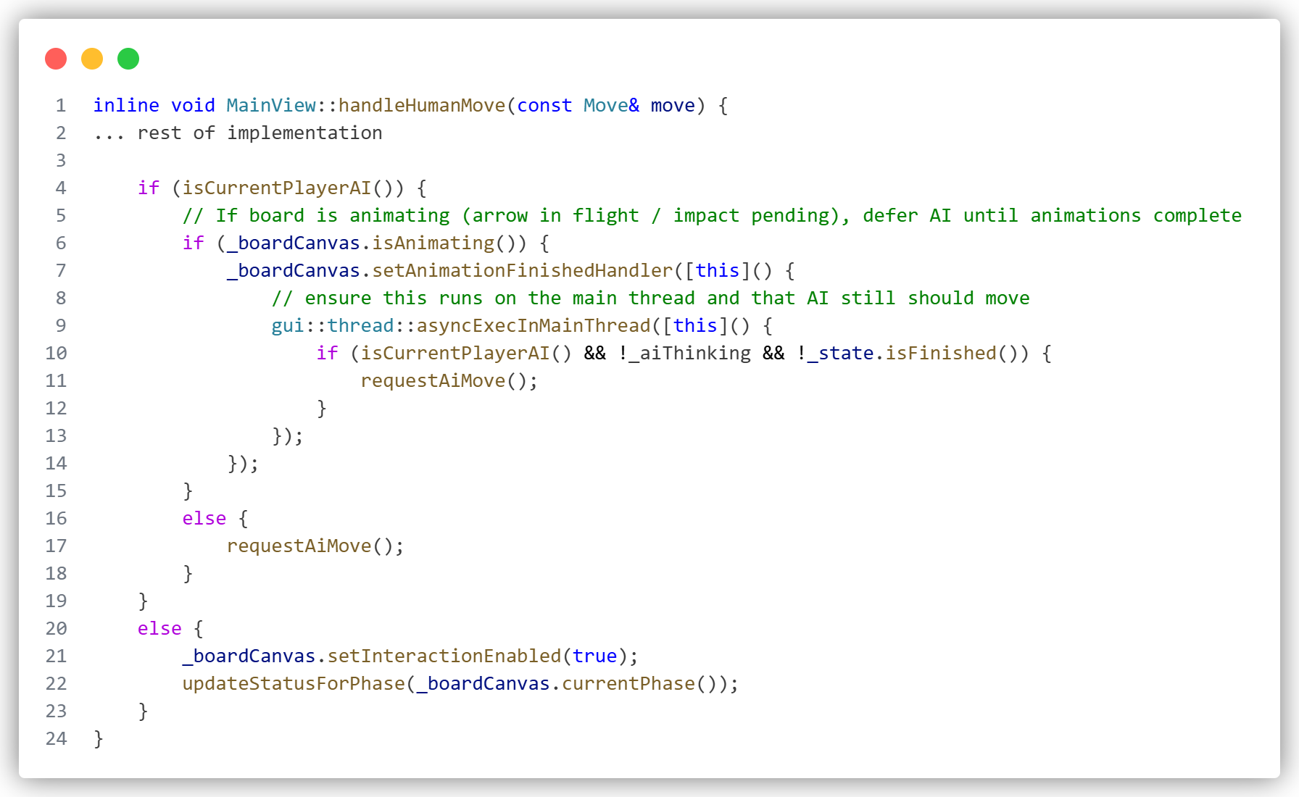
Difficulty Scaling: The difficulty levels (Easy, Medium, Hard) are not just arbitrary labels; they fundamentally change how the engine behaves. We implemented Variable Depth Logic in Algorithms.h.
- Easy: Shallow search (Depth 1-2).
- Medium: Standard depth (Depth 3-4).
- Hard: Deep search (Depth 5+) with a "Variable Depth" optimization that searches only the top 6 most promising moves deeply, while shallow-searching the rest to save time.
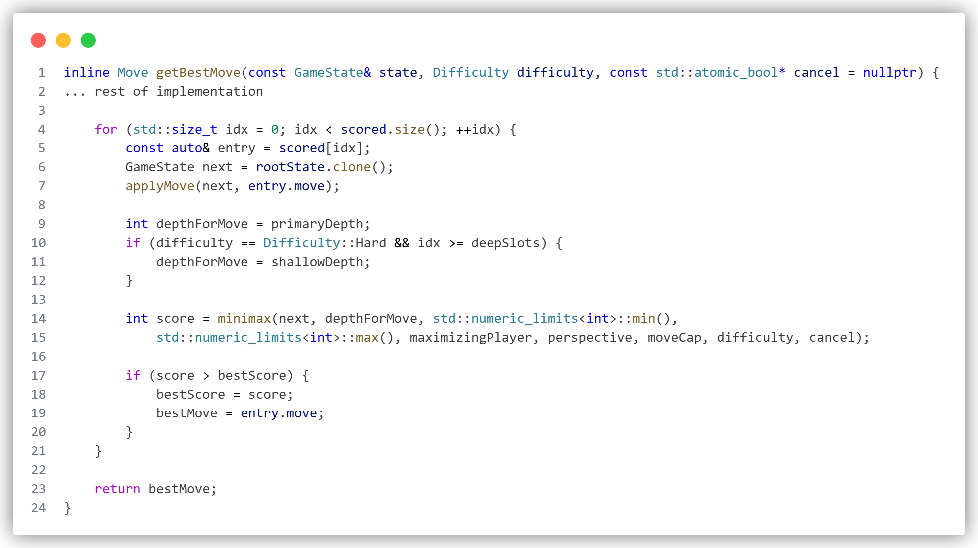

Team Responsibilities and Task Distribution

- Emin Hadžiabdić
  - Development of the graphical user interface (GUI) using natID
  - Integration of GUI elements with the game engine
  - Ensuring smooth user interaction and visual consistency
- Muhammed Pašić
  - Implementation of core game rules and logic
  - Validation of legal moves, board updates, and turn management
  - Collaboration with engine developer to ensure correct rule execution
- Armin Memišević
  - Development of the main game engine
  - Implementation of the Minimax algorithm and alpha–beta pruning.
  - Coordination with rule and GUI components to ensure full game functionality

